**Continuous Integration in Nokia**

I am pretty sure you all have used **Nokia** phones at some point in your life. In a software product development project at Nokia there was a process called **Nightly builds**. Nightly builds can be thought of as a predecessor to Continuous Integration. It means that every night an automated system pulls the code added to the shared repository throughout the day and builds that code. The idea is quite similar to Continuous Integration, but since the code that was built at night was quite large, locating and fixing of bugs was a real pain. Due to this, Nokia adopted Continuous Integration (CI). As a result, every commit made to the source code in the repository was built. If the build result shows that there is a bug in the code, then the developers only need to check that particular commit. This significantly reduced the time required to release new software.

Now is the correct time to understand how Jenkins achieves Continuous Integration.

**Continuous Integration With Jenkins**

Let us imagine a scenario where the complete source code of the application was built and then deployed on test server for testing. It sounds like a perfect way to develop a software, but, this process has many flaws. I will try to explain them one by one:

* Developers have to wait till the complete software is developed for the test results.
* There is a high possibility that the test results might show multiple bugs. It was tough for developers to locate those bugs because they have to check the entire source code of the application.
* It slows the software delivery process.
* Continuous feedback pertaining to things like coding or architectural issues, build failures, test status and file release uploads was missing due to which the quality of software can go down.
* The whole process was manual which increases the risk of frequent failure.

It is evident from the above stated problems that not only the software delivery process became slow but the quality of software also went down. This leads to customer dissatisfaction. So to overcome such a chaos there was a dire need for a system to exist where developers can continuously trigger a build and test for every change made in the source code. This is what CI is all about. Jenkins is the most mature CI tool available so let us see how Continuous Integration with Jenkins overcame the above shortcomings.

I will first explain you a generic flow diagram of Continuous Integration with Jenkins so that it becomes self explanatory, how Jenkins overcomes the above shortcomings:

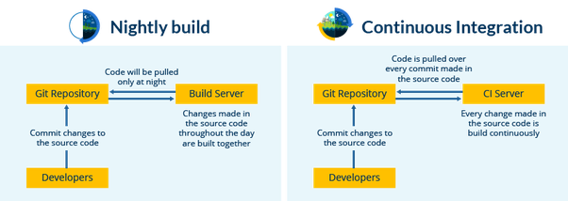

The above diagram is depicting the following functions:

* First, a developer commits the code to the source code repository. Meanwhile, the Jenkins server checks the repository at regular intervals for changes.
* Soon after a commit occurs, the Jenkins server detects the changes that have occurred in the source code repository. Jenkins will pull those changes and will start preparing a new build.
* If the build fails, then the concerned team will be notified.
* If built is successful, then Jenkins deploys the built in the test server.
* After testing, Jenkins generates a feedback and then notifies the developers about the build and test results.
* It will continue to check the  source code repository for changes made in the source code and the whole process keeps on repeating.

You now know how Jenkins overcomes the traditional SDLC shortcomings. The table below shows the comparison between “Before and After Jenkins”.

|  |  |
| --- | --- |
| **Before Jenkins** | **After Jenkins** |
| The entire source code was built and then tested. Locating and fixing bugs in the event of build and test failure was difficult and time consuming, which in turn slows the software delivery process. | Every commit made in the source code is built and tested. So, instead of checking the entire source code developers only need to focus on a particular commit. This leads to frequent new software releases. |
| Developers have to wait for test results | Developers know the test result of every commit made in the source code on the run. |
| The whole process is manual | You only need to commit changes to the source code and Jenkins will automate the rest of the process for you. |